**OBJECTIVE QUESTIONS**

1. **What is the total no. of tables present in the data?**

There are 5 tables present in a data that are

* Raw data
* Country Description
* Online Currency Rate
* Currency Conversion Rate
* Prize Bucket range

1. **What is the total no. of attributes present in the data?**

There are 37 attributes present in a data

* Raw data – 27
* Country Description -2
* Online Currency rate -3
* Currency Conversion -3
* Prize Bucket range -2

1. **How many categorical columns are there in the data?**

There are **26** Categorical Columns present in a data

* Raw Data -**20**(Restaurant_id, Restaurant_name, Country_Code, city, Address, Locality, Locality varbose, Cuisines, New_Cuisines, Currency, has_table_booking, has_online_delivery, is_delivering_now, Switch_to_Order_menu, Price_range, Price_bucket_range, Rating, Date_key_Opening, New_date_key_Opening, Year_date_key_opening, Country).
* Country Description -**2**(Country Code, Country Name)
* Online Currency Rate -**1**(Country)
* Currency Conversion -**2**(Country, Currency)
* Prize bucket range -**1**(Bucket Range)

1. **The data consists of some inconsistent and missing values so ensure that the data used for further analysis is cleaned.**

* Restaurant_Id ordered ascendingly.
* Updated the missing Cuisines in the New Cuisines using most common cuisines from the corresponding country.
* (By Using **Sort and Filter** Filtered themissing Cuisines and Found all the missing Cuisines are in the Country **United States of America-Mexican city** and most Common Cuisine from the Mexican city selected and updated in the new column)
* Converted AvgCost_of_two into Indian rupees for Common reference purpose
* (The Avg Cost of Two contains the Cost in a different Country Currency, for Easy way of study purpose Converted all the Country Currency to Indian rupees using the Currency Conversion table[imported from online] and it will updated the conversion automatically when the value of currency changes
* By Using VLOOKUP Function filled the Average Cost of two in Indian rupees in the new Column.
* Updated Date column into a proper date format.
* By using the proper date Function **Date Value** updated the **date key opening** into new Column and updated the one more column **Year date key opening** for additional study purpose.

1. **Using the Lookup functions, fill up the countries in the original data using the country code.**

Approach:

* There is Country table and the Raw data table separately and Both tables Contain the Common Column Country Code.
* By suing the VLOOKUP Function fill the Country Column in Raw data table.
* ***Formula*** =VLOOKUP (C2,'country description’! $A$2: $B$17,2,0)
* Created a New Column named **Country** and fill up the Country from Country Description table using above formula with exact match of Country Code.

1. **Create a table to represent the number of restaurants opened in each country.**

Approach:

* Create a table to represent the number of restaurants opened in each country using a pivot table.

Explanation:

* Step 1: Select all the cells in the "Raw Data" worksheet.
* Step 2: Click on Insert -> Pivot Table and specify the location where you want to insert the pivot table.
* Step 3: Once the pivot table is created, drag the "Country" field into the Rows section.
* Step 4: Drag the "RestaurantID" (or another unique identifier for each restaurant) into the Values section. By default, it might display as a sum, so change it to Count to get the number of restaurants.

Visualisation:

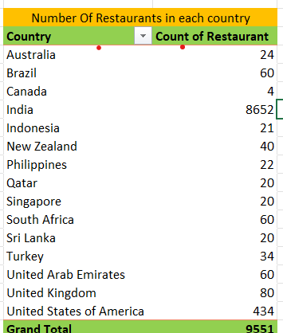

1. **the management wants to look at the number of restaurants opened each year, so provide them with something here.**

Approach:

* + 1. Extract the Year from Dates:
  + Create a new column that extracts the year from the "DateKey_Opening" using the YEAR function.
    1. Use a Pivot Table:
  + Represent the number of restaurants opened each year by creating a pivot table.

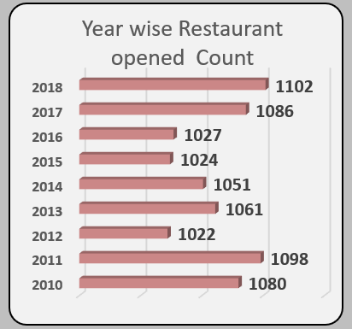

1. **What is the total number of restaurants in India in the price range of 4?**

Approach:

* By using the Conditional aggregation (Countifs-formula) can find the answer to the question.
* ***Formula***=COUNTIFS ('Raw Data’! Q2:Q9552,"4",'Raw Data’! AA2:AA9552,"India")

Output:

* Ans= There are **388** restaurants in India with prize range 4

1. **What is the average number of voters for the restaurants in each country according to the data?**

Approach:

* To calculate the average number of voters for restaurants in each country, create a pivot table.

Explanation:

* Select all cells in the "Raw Data" sheet.
* Go to Insert -> Pivot Table, and specify the location for the pivot table.
* Drag "Country" to the Rows section and "Votes" to the Values section. By default, it will show the sum; change this to average.

Visualization:

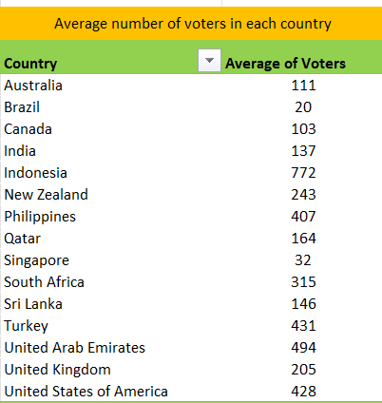

1. **Calculate the average rating for all the restaurants that have price_range < 4 and provide online delivery. Use only the “IF” function, Logical Operators, and Aggregation functions to solve this problem. [Note: Don’t use Conditional aggregation in this question.]**

Approach

* To calculate the average rating for restaurants with a price range less than 4 and that offer online delivery, use the IF function along with logical operators and aggregation functions.

Explanation

* The idea is to apply the conditions within an IF function using the AND operator. If both conditions are met, the function will calculate the average rating.

Formula

=AVERAGE(IF((Table1[Has_Online_delivery]="Yes")*(Table1[Price_range]<4),Table1[Rating]))

Output

* **Ans = 3.27381**

1. **Using Conditional formatting highlight the rows of restaurants that are located in the countries or cities that you’ve suggested to the management for opening new restaurants.**

Approach

* To highlight the rows of restaurants located in the countries or cities suggested for new restaurant openings, use conditional formatting.

Explanation

* Select the "Restaurant Name" column.
* Go to Home -> Conditional Formatting -> New Rule.
* Choose Use a formula to determine which cells to format.
* Enter the formula: =$AA1="Sri Lanka", then click Apply and OK.
* And again, repeat the same for “Turkey”, “South Africa”, “News Zealand”, and “UAE”

Visualisation:

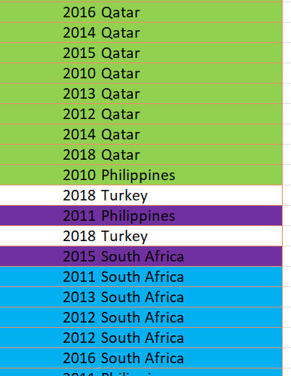

1. **Create a new customized price column that consists of the abbreviation/symbol of the currency along with the Average_cost_for_two value. [Use string operations to do this task]**

Approach:

* Created a Column Name **New Customized prize** and By using MID,FIND and CONCAT fill up the column that contains symbol of currency and Average Cost of Two.
* Currency Column Contains the abbreviation with Currency symbol and and average Cost of two Contains the expenditure of two peoples.
* By using the MID, Find, Concatenation Function fill the New Customized Prize Column.

Suggestion:

* *Formula*

=MID(L2,FIND("(",L2)+1,FIND(")",L2)-FIND("(",L2)-1)&" "&S2

1. **How can you create an array formula in Excel or Google Sheets to count the number of restaurants listed that do not offer online delivery, are in the lowest price range, and have an average cost for two people less than or equal to 250 Indian Rupees?**

* To count the number of restaurants that do not offer online delivery, are in the lowest price range, and have an average cost for two people less than or equal to 250 Indian Rupees,
* use the following array formula:
* Formula =SUMPRODUCT (('Raw Data’! N2:N9552="No”) *('Raw Data’! Q2:Q9552=1) *('Raw Data’! T2:T9552<=250))
* The Final output is Ans=1694

**SUBJECTIVE QUESTION**

1. **Suggest a few countries where the team can open newer restaurants with lesser competition. Which visualization/technique will you use here to justify the suggestions?**

Approach:

* By analysing different insights from the data, I can recommend countries where the team can open new restaurants with less competition.

Explanation:

The best countries to open new restaurants are those where:

* There are fewer than 100 restaurants.
* The average rating is 3.9 or higher.
* The average cost for two people is less than 6000 INR.
* The number of voters is more than 140.

Insights:

Based on these criteria, the suggested countries are South Africa, Sri Lanka, Turkey, News Zealand, Qatar and UAE.

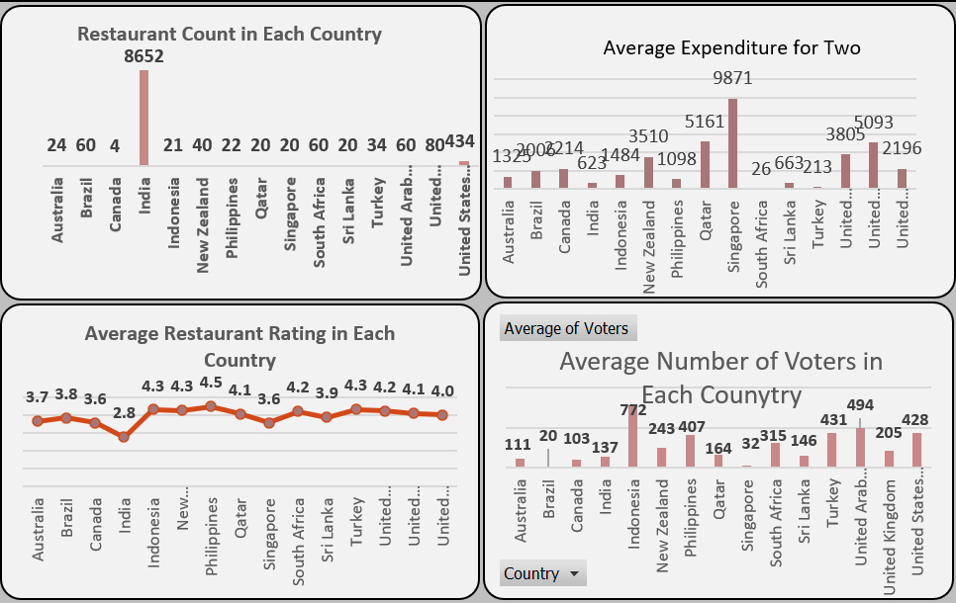

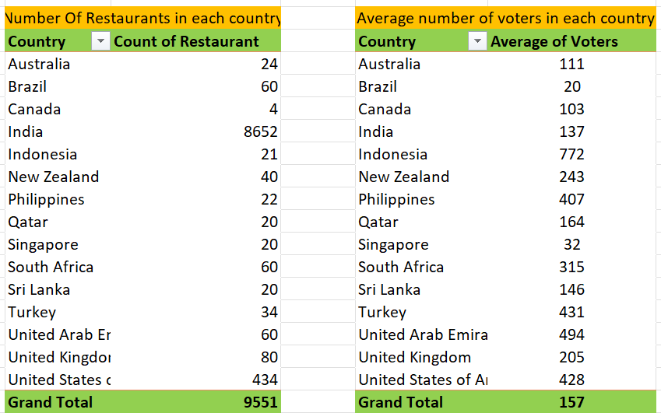

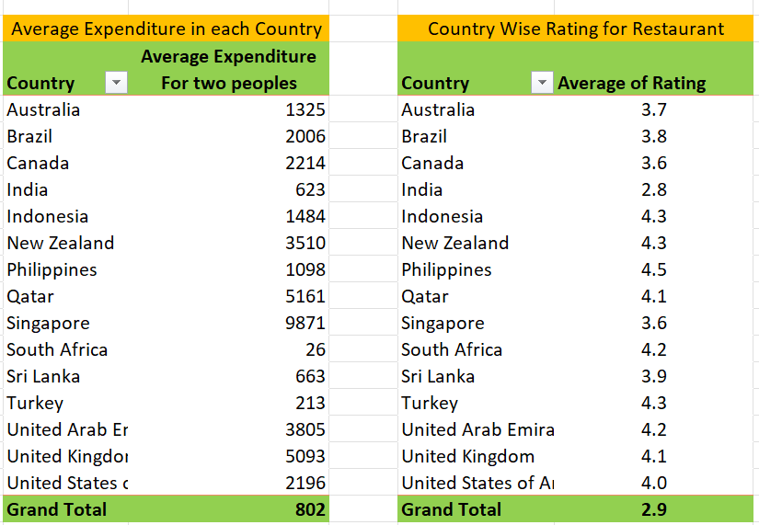

Recomendation:

These visualizations will provide a clear, data-driven basis for recommending the most promising countries for new restaurant openings.

1. **Come up with the names of States and cities in the suggested countries suitable for opening restaurants.**

Approach:

Based on the average rating 3.9 or higher, the count of restaurants<100, and average price range <6000 INR selected the Suitable Countries. In that Countries The most suitable locations to open newer Restaurants are.

Result:

* South Africa: Cape Town, Inner City, Johannesburg, Pretoria, Randburg, Sandton
* Sri Lanka: Colombo
* Turkey: Ankara, Istanbul
* New Zealand: Auckland, Wellington City
* Qatar: Doha
* UAE: Abu Dhabi, Dubai, Sharjah

1. **According to the countries you suggested, what is the current quality regarding ratings for restaurants that are open there?**

Approach:

* Created a pivot table connected with a chart and a slicer to visualize the data effectively.

Visualization:

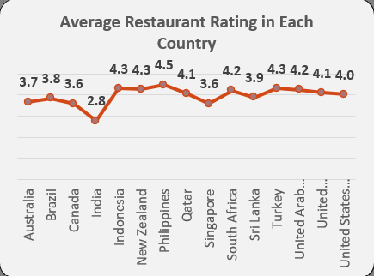

Insights:

* We can able to the analyse that the selected country is having better rating above 3.9
* New Zealand – 4.3
* Qatar – 4.1
* South Africa – 4.2
* Sri Lanka – 3.9
* Turkey - 4.3
* United Arab Emirate – 4.2

Recommendation

* The average restaurant rating in Sri Lanka is 3.9; improving services by adding online ordering, reservation capabilities, and a wider selection of food could raise the rating and greatly increase customer satisfaction, making it a good contender for new restaurant openings.

1. **Also, what is the current expenditure on food in the suggested countries, so we can keep our financial expenditure in control?**

Approach:

* A pivot table is used to assess the current food expenditure in the recommended countries and to help manage financial costs effectively.

Visualisation:

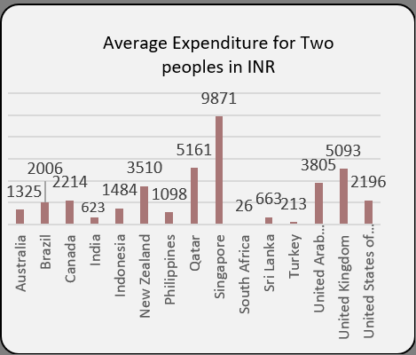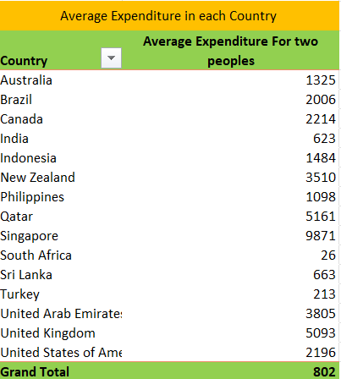

Insights:

* With the lowest average cost, South Africa is the best place to open new restaurants. Singapore has the highest average cost of dining for two persons, followed by the Philippines, and so on.

Suggestion:

* It would be difficult to keep expenses stable in Singapore and the Philippines because of their extremely high spending levels. Nonetheless, concentrating on nations with more affordable prices and high restaurant reviews, such as Turkey, Sri Lanka, and South Africa.We may properly manage financial spending by employing this strategy to successfully monitor and regulate food expenditure in the specified countries.

1. **Come up with the names of restaurants from the recommended states that are our biggest competitors and also those that are rated in the lower brackets, i.e. 1-2 or 2-3.**

Approach:

* To identify the biggest competitors and those rated in the lower brackets (1-2 or 2-3) from the recommended states, we'll follow this approach:

Explanation:

* Using average expenditure (corresponding Countries average) and Rating

1. First, identify restaurants marked as competitors.

by using if function added restaurant names to new column Competitor whose Expenditure is lower than the corresponding Countries average expenditure and the condition of Rating of Restaurant falling between 1 to 3 and additionally.

1. By using above 2 conditions extract the Restaurant name to new column **competitor** (Refer Work Sheet name-Sheet1).

Insights:

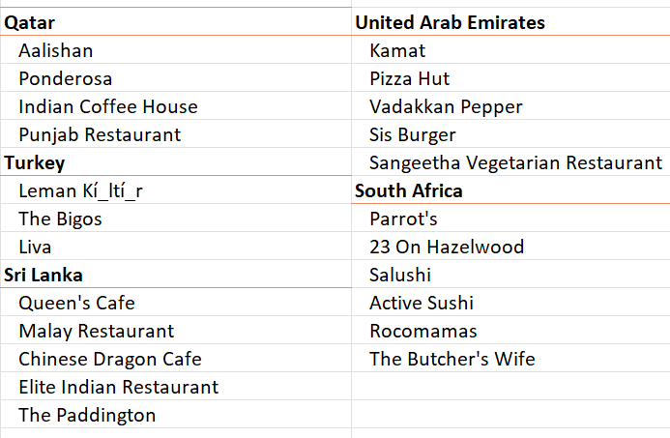

Results:

* These restaurants are considered significant competitors in their respective regions and have been rated in the lower brackets, indicating potential areas of focus or concern.

1. **Which cuisines should we focus on in the newer restaurants to get better feedback? Does the choice of cuisines affect the restaurant ratings?**

Approach:

* By analysing various insights from the data, we can determine which cuisines to focus on in new restaurants to potentially improve customer feedback and ratings.

Insights:

* The below Cuisines are the most widely providing and top-rated Cuisines in the selected countries

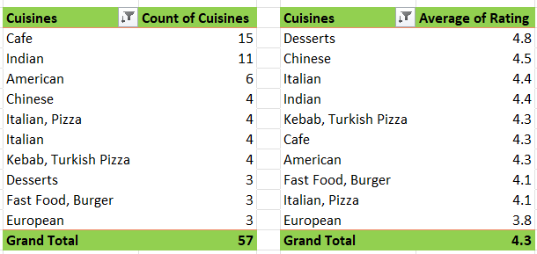

Recommendation:

* By using the above method, we can select the top-rated Cuisines and most widely providing Cuisines in the restaurants for each Country to open a newer Restaurants.
* Strategically selecting the top cuisines can significantly enhance customer satisfaction, leading to positive feedback and higher ratings.

1. **According to our current data, should we go for online delivery and table booking? Does that affect the customer’s ratings?**

Approach:

* Created a line chart using Pivot table for Online delivery rating and table booking rating.

Insights:

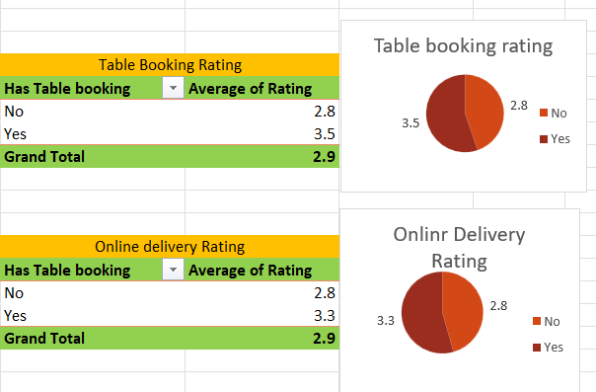

Recommendation:

* There is a positive trend line rating in the available table booking restaurants compared to non-available table booking restaurants.
* There is not much differ in rating in both the restaurants whose having online delivery and not having online delivery.
* Those restaurants which are having online delivery and table booking both are showing an increase in ratings. Therefore, we can say that online delivery and table booking will affects the customer’s ratings.

1. **Should the team keep the rate of cuisines higher? Will that affect the feedback? According to our data are the rates of cuisines and ratings, correlated?**

Approach:

* Created a Trend line chart using pivot table that contains Rating in row and Cost in Values

Explanation:

* Created a Pivot table that Contains Rating in Row and average expenditure of two peoples in the Value. And in the value field setting, select change the sum to average it will give you the average of Average expenditure of two (refer Work sheet 2).
* Then create a line chart, for better analysis added a trend line to the chart.

Insights:

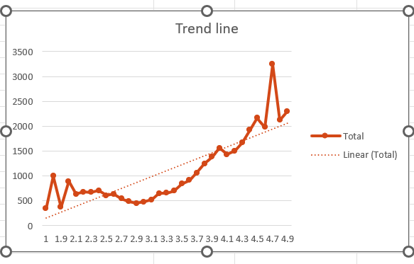

Suggestion:

* As the linear forecast trendline is moving slightly upward direction and the correlation coefficient is moving towards +1, therefore, we can say that the rates of cuisines and ratings are positively correlated i.e as one variable increases, the other tends to also increase

1. **What is the distribution of the number of restaurants of different price ranges in all the countries?**

Approach:

* Created a pivot table with Price Range in rows and Count of Restaurant ID in values.
* Added a slicer to filter data by country.

Explanation:

* This setup allows for analysing the distribution of restaurants across different price ranges.
* The slicer enables viewing the distribution by country.

Visualisation

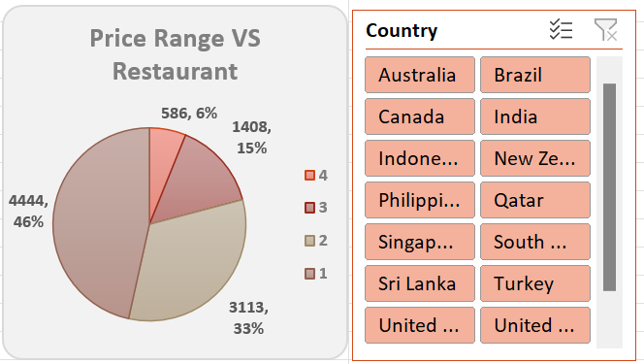

Result:

* Gives a clear picture of how restaurants are spread out across price points in each nation; aids in understanding of pricing tactics and market division for the launch of new restaurants.

1. **Explain your approach in brief for suggesting countries/cities in order to open new restaurants, if the objective and subjective questions would have not been given to assist you. [you have to give bullet pointers in order to answer this question]**

Approach:

* According to the study the most suitable countries for opening new restaurants are South Africa, Sri Lanka, Turkey, News Zealand, Qatar and UAE.
* Based on the average rating 3.9 or higher, the count of restaurants<100, and average price range <6000 INR selected the Suitable Countries. In that Countries The most suitable locations to open newer Restaurants are.
* South Africa: Cape Town, Inner City, Johannesburg, Pretoria, Randburg, Sandton
* Sri Lanka: Colombo
* Turkey: Ankara, Istanbul
* New Zealand: Auckland, Wellington City
* Qatar: Doha
* UAE: Abu Dhabi, Dubai, Sharjah
* According to the selected Countries below Cuisines are most repeated cuisines and top-rated Cuisines in the selected Countries we need to focus for newer restaurants



* Based on the table booking and online delivery analysis, both showing the positive impact on restaurant rating so the newer restaurants contain online delivery and table booking which will increase the rate of the restaurant
* The data shows the rating of Cuisines and average Expenditure of two peoples is linearly increasing so we can keep the rate of cuisines higher accordingly.

